***C***

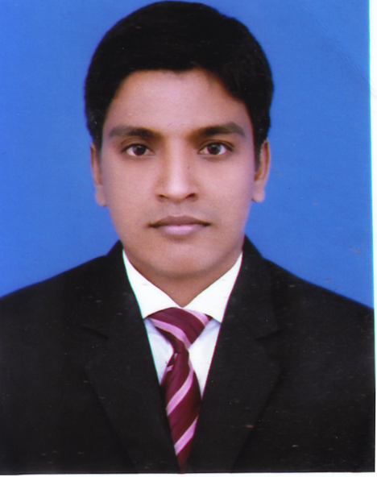

c urriculum Vitae

**Md. Abdulla Almamun**

**House no. 12, Road no. 09, Lane 2,**

**Section-11, Mipur, Dhaka- 1216**

**E-mail:** [**almamun2058@gmail.com**](mailto:almamun2058@gmail.com)

**Mob: +8801723979172**

|  |  |  |  |
| --- | --- | --- | --- |
| **CAREER OBJECTIVES** | Obtain a position as an elementary School Teacher that will utilize my strong dedication to children’s development and to their educational needs. | | |
| |  |  | | --- | --- | | **EXPERIENCE** | 1. Glory International School and College ( January 2019- present) 2. Assistant Teacher in English at Mirpur Cadet Coaching (January 2018 -present) | | | | |
|  | | | |
| **ACADEMIC QUALIFICATION** | | Degree  Subject/Dept.  University  Duration  Year of passing  Result | : **M.A (Masters)**  : English  : Begum Rokeya University, Rangpur  : 1 Year  : 2014  : CGPA-3.22 (Out of 4.00) |
| Degree  Subject/Dept. University  Duration  Year of passing  Result | : **B.A (Honor’s)**  : English  : Begum Rokeya University, Rangpur  : 4 Year  : 2013  : CGPA-2.86 (Out of 4.00) |
| Examination  Institute  Board  Group/Dicipline  Year of passing  Result | : **Higher** **Secondary Certificate (**Alim**)**  : Salandar Islamia Kamil Madrasah  : Madrasah  : Humanities  : 2009  : 4.58 (Out of 5.00) |
| Examination  Institute  Board  Group/Dicipline  Year of passing  Result | : **Secondary School Certificate (**Dakhil**)**  : Khamar Bhopla Dakhil Madrasah  : Madrasah  : Humanities  : 2007  : 4.75 (Out of 5.00) |

|  |  |
| --- | --- |
| **COMPUTER SKILL** | * **Operating System :** Win-XP. * **Package :** MS Word, Ms Power Point, MS Excel. * **Others :** Web Browsing, E-mailing. |

|  |  |
| --- | --- |
| **LANGUAGE**  **PROFICIENCY** | Language Writing Reading Listening Speaking Bengali Excellent Excellent Excellent Excellent  English Excellent Excellent Excellent Excellent |

|  |  |  |
| --- | --- | --- |
| **PERSONAL INFORMATION** | Name  Father’s Name  Mother’s Name  Date of Birth  Sex  Religion  Marital Status  Height  Weight  Nationality  National ID | : **Md. Abdulla Almamun**  : Hafiz Uddin  : Latifa Khatun  : 10 December, 1992  : Male  : Islam (Sunni)  : Unmarried  : 5’-6’’  : 64 Kg  : Bangladeshi (By Birth).  :19929419442000462 |

|  |  |  |
| --- | --- | --- |
| **PERMANENT**  **ADDRESS** | Village  P.O.  Upozila  District | : Khamar Bhopla  : Goreya  : Thakurgaon  : Thakurgaon |

|  |  |  |
| --- | --- | --- |
| **REFERENCES** | **Zeenat Sharmin**  Assistant Professor  Department of English  Faculty of Arts  Begum Rokeya University, Rangpur  Mobile: 01712558219 | Mohammad Mohsin Ali  Lecturer  Mirpur University College  Mirpur-2, Dhaka -1216.  Mobile: 01733128652 |

**Declaration**

I hereby declare that the information given above by me is true, complete and convict to best of my knowledge.

**Signature of Candidate**

.....................................

Md. Abdulla Almamun

Date: ..........................